** 

***FUNDACION CATALINA DE MARÍA***

***LICEO SAGRADO CORAZÓN- COPIAPÓ***

***71 AÑOS, 1949 – 2020***

**STUDY GUIDE UNIT 0 ELEVENTH GRADE**

|  |
| --- |
| Aprendizajes esperados:   * Conocer y usar la voz en inglés que expresa la relación del sujeto con la acción a través del verbo. La voz tiene dos valores: activa y pasiva. * Reconocer y utilizar, en forma correcta, sabiendo que en la voz activa participa un verbo, y en la voz pasiva debe estar el verbo to be más el pasado participio del segundo verbo. |

**NAME: ____________________________ CLASS: ___________ MARK: ____**

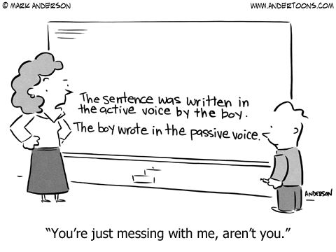

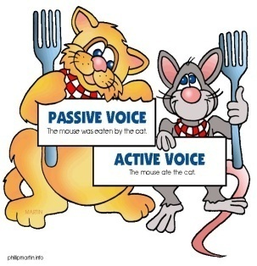

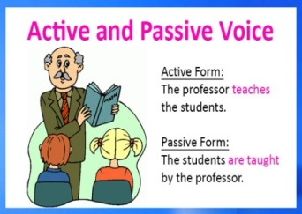

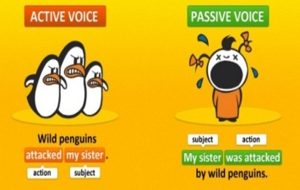

**Passive Voice**

Everybody drinks water.  
Water is drunk by everybody.

"Voice" is a [grammatical category](https://www.englishclub.com/grammar/sentence/category.htm) that applies to verbs. Voice in English expresses the relationship of the subject to the action. Voice has two values:

* **active**: the subject does the action
* **passive**: the subject receives the action

|  |  |  |  |  |  |
| --- | --- | --- | --- | --- | --- |
| Shakespeare | wrote | Hamlet. |  |  |  |
|  |  | Hamlet | was written | by | Shakespeare. |

The **active voice** is the "normal" voice - the one that we use most of the time. In the active voice, the **object** receives the action of the verb:

|  |  |  |  |
| --- | --- | --- | --- |
| **active** | **subject** | **verb** | **object** |
|  | → | |
| Cats | eat | mice. |

The **passive voice** is less common. In the passive voice, the **subject** receives the action of the verb:

|  |  |  |  |
| --- | --- | --- | --- |
| **passive** | **subject** | **verbs** | **object** |
| ← | |  |
| Mice | are eaten | by cats. |

See how the **object** of the active verb becomes the **subject** of the passive verb:

|  |  |  |  |
| --- | --- | --- | --- |
|  | **subject** | **verb** | **object** |
| **active** | Everybody | drinks | **water**. |
| **passive** | **Water** | is drunk | by everybody. |

**Active Voice**

Cats eat mice.

The active voice is the "normal" voice of an English sentence. Intransitive verbs (verbs with no direct object) are always in the active voice. Transitive verbs are usually in the active voice:

Important:

In the active voice there is just one verb.

|  |  |  |
| --- | --- | --- |
| **subject** | **verb** |  |
| Johnny | laughed. |  |
| Anton | got up | late. |
| People | drink | water. |

In the active voice, the subject is the person or thing responsible for the action of the verb.

All tenses are possible in the active voice, as well as all sentence types, positive, negative or question.

**Use of active**

The active voice is:

* direct and specific
* uses fewer words - always a good thing
* dynamic

Except on occasions when the passive voice is actually useful, the active voice is the voice of choice.

**Passive Voice**

Mice are eaten by cats.

Important:

In the passive voice there are two verbs.

Although the passive voice is less common than the active voice, there are several good reasons to sometimes use the passive. On this page we look at how to construct the passive voice and when and why to use it.

**How do we make the passive?**

The basic structure of a **passive** clause is very simple:

|  |  |  |  |  |  |  |  |  |
| --- | --- | --- | --- | --- | --- | --- | --- | --- |
| subject | + | auxiliary verb *be* | + | main verb *past participle* | + | *by* | + | agent |
|  | | | | | optional | | | |

The auxiliary *be* is conjugated in all tenses. The main verb is always the past participle. The agent is the original "doer" of the action.

Look at some examples:

| **subject** | **auxiliary verb *be*** | **main verb  *past participle*** | ***by*** |  |
| --- | --- | --- | --- | --- |
| I | am | employed | by | Apple. |
| You | will be | woken |  | at 6. |
| It | will have been | finished |  | by then. |
| We | have been | notified | by | Head Office. |
| You | are being | transferred |  | next week. |
| They | will be | paid. |  |  |

Notice above↑:

* auxiliary *be* can be conjugated for all persons and tenses
* main verb is invariable: *past participle*
* if there is an agent *(Apple, Head Office)*, it is introduced by *by*

**Agentless passive**

The subject of an active sentence "does" the action. In a passive sentence, we express the doer (or agent) through a *by* phrase (the long passive) or, very often, we remove it completely (the short passive). In the following example, the agent is "the Allies":

|  |  |  |
| --- | --- | --- |
| **active** | | The Allies firebombed Dresden. |
| **passive** | **long** | Dresden was firebombed by the Allies. |
| **short** | Dresden was firebombed. |

The short passive is also known as the "agentless passive". Soon you will see how useful it can be.

**Negatives and questions**

The table below shows examples of the passive with negative sentences, question sentences and negative-question sentences:

|  |  | **subject** |  |  | **auxiliary verb *be*** |  | **main verb *past participle*** |  |
| --- | --- | --- | --- | --- | --- | --- | --- | --- |
|  |  | You |  |  | are | not | paid | to watch YouTube. |
|  |  |  |  |  |  |  |  |
|  | Are | they |  |  |  |  | cleaned | regularly? |
|  |  |  |  |  |  |  |  |
|  | Is | he |  |  |  | not | notified | immediately? |